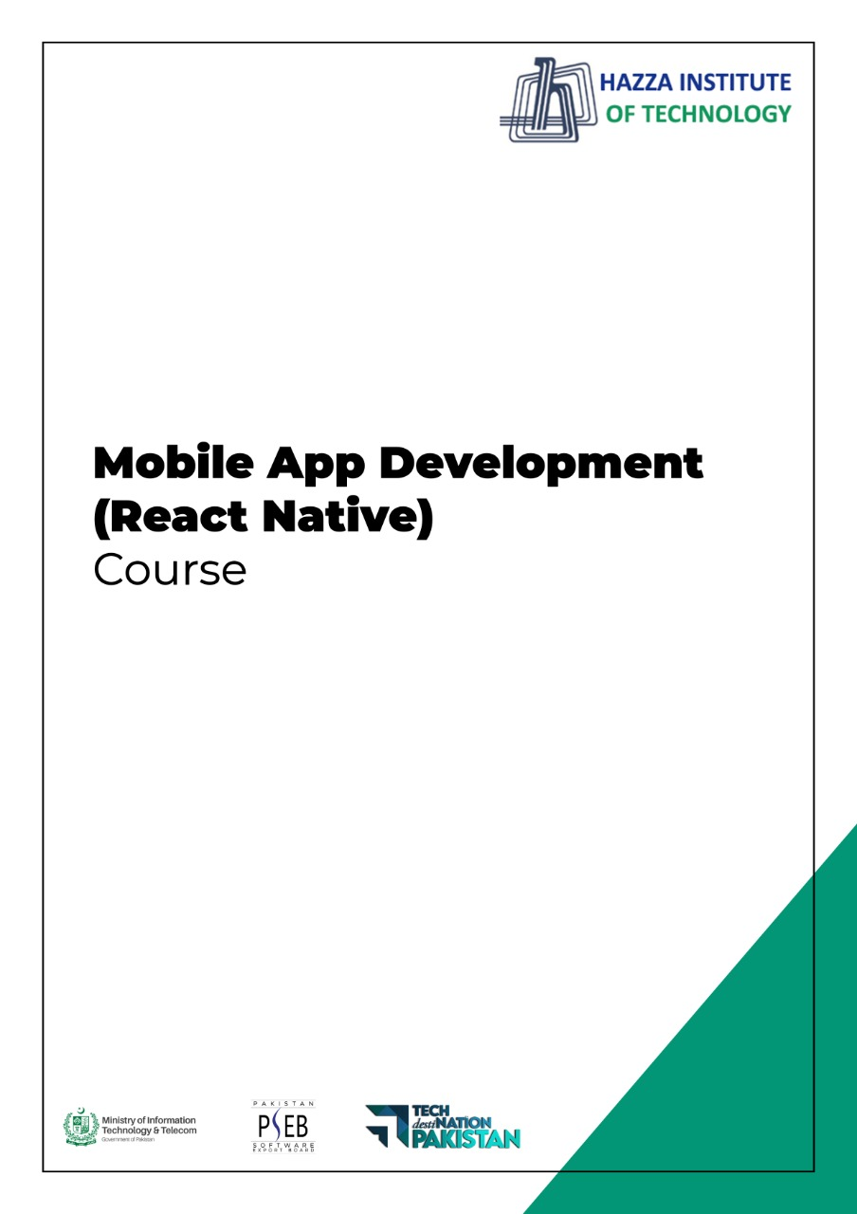
(Flutter: Dart)
Lab 2 (Session 1)

Total Time:
3 hours (sessions-1)

Pre-Lab Activities:
  - Familiar with dartpad for dart Editor

Learning Outcomes:
  - Demonstrate the basic knowledge of Dart.

Student Activities:
  - Open Dartpad, and do some exercise for dart

Lab Tasks 1:
Create a program that asks the user to enter their name and their age. Print out a message that tells how many years they have to be 100 years old.

Lab Tasks 2:
Ask the user for a number. Depending on whether the number is even or odd, print out an appropriate message to the user.

Lab Tasks 3:
Take a list, say for example this one:
a = [1, 1, 2, 3, 5, 8, 13, 21, 34, 55, 89]
and write a program that prints out all the elements of the list that are less than 5.

Lab Tasks 4:
Create a program that asks the user for a number and then prints out a list of all the divisors of that number.
If you don’t know what a divisor is, it is a number that divides evenly into another number. For example, 13 is a divisor of 26 because 26 / 13 has no remainder.

Lab Tasks 5:
Take two lists, for example:
a = [1, 1, 2, 3, 5, 8, 13, 21, 34, 55, 89]

b = [1, 2, 3, 4, 5, 6, 7, 8, 9, 10, 11, 12, 13]
and write a program that returns a list that contains only the elements that are common between them (without duplicates). Make sure your program works on two lists of different sizes.

Lab Tasks 6:
Ask the user for a string and print out whether this string is a palindrome or not.
A palindrome is a string that reads the same forwards and backwards.

Lab Tasks 7:
Let’s say you are given a list saved in a variable:
a = [1, 4, 9, 16, 25, 36, 49, 64, 81, 100].
Write a Dart code that takes this list and makes a new list that has only the even elements of this list in it.

Lab Solutions:

LAB 2.1 :
import 'dart:io';

void main() {
stdout.write("What's your name? ");
String name = stdin.readLineSync();

print("Hi, $name! What is your age?");
int age = int.parse(stdin.readLineSync());

int yearsToHunderd = 100 - age;
print("$name, You have $yearsToHunderd years to be 100");
}

LAB 2.2 :
import 'dart:io';

void main() {
stdout.write("Hi, please choose a number: ");
int number = int.parse(stdin.readLineSync());

if (number % 2 == 0) {
print("Chosen number is even");
}
else {
print("Chosen number is odd");
}
}

LAB 2.3 :
void main() {
List<int> a = [1, 1, 2, 3, 5, 8, 13, 21, 34, 55, 89];

for (var i in a) {
if (i < 5) {
print(i);
}
}

// One liner
print([for (var i in a) if (i < 5) i]);
}

LAB 2.4 :
import 'dart:io';

void main() {
stdout.write("Please choose a number: ");
int number = int.parse(stdin.readLineSync());
for (var i = 1; i <= number; i++) {
if (number % i == 0) {
print(i);
}
}
}

LAB 2.5 :
void main() {
List<int> a = [1, 1, 2, 3, 5, 8, 13, 21, 34, 55, 89];
List<int> b = [1, 2, 3, 4, 5, 6, 7, 8, 9, 10, 11, 12, 13, 89];
Set<int> c = {};

for (var i in a) {
for (var j in b) {
if (i == j) {
c.add(i);
}
}
}
print(c.toList());

// One liner using set intersections
print(Set.from(a).intersection(Set.from(b)).toList());
}

LAB 2.6 :
import 'dart:io';

void main() {

stdout.write("Please give a word: ");
String input = stdin.readLineSync().toLowerCase();
String revInput = input.split('').reversed.join('');

// Ternary operator
input == revInput
? print("The word is palindrome")
: print("The word is not a palindrome");
}

LAB 2.7 :
void main() {
List<int> a = [1, 4, 9, 16, 25, 36, 49, 64, 81, 100];

int i = 0;
List<int> l = [];

for (var e in a) {
if (++i % 2 == 0) {
l.add(e);
}
}
print(l);

// One liner
print([for (var e in a) if (++i % 2 == 0) e]);
}

